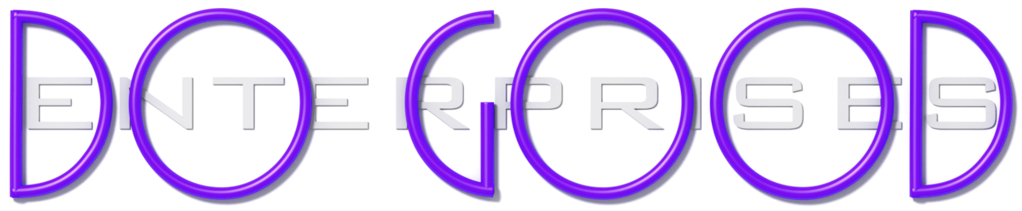

EM2 Vs Raise the Bar enterprises Vs Center for Empowerment Vs DO GOOD enterprises

The following document provides a simple description of the four entities you will be involved in (and their relationship to one another) as you embark on this program. You may choose to focus on one entity over any another if you choose.

DO GOOD enterprises is a 501 (c)3 nonprofit social enterprise and resource center. It provides information and resources to those who wish to ‘create a better world’ including, but not limited to EM Squared, Raise the Bar, The Center for Empowerment, and those who team with them. DO GOOD was listed at the top of this document as it was through DO GOOD that the following three entities were brought together.

Its most distinct features are:
- The sole purpose of DO GOOD is to help others ‘do good’. DO GOOD is a resource center for ‘heroes’ and would be ‘heroes’.
- DO GOOD uses funds and donations to find and provide additional resources for heroic individuals and causes, as well as to help fund those that meet its criteria.
- As a nonprofit social enterprise, DO GOOD does not rely entirely on donations, it also ‘earns’ its way by offering products to the general public that ‘help create a better world’ and by sponsoring special events.

EM Squared is a social enterprise that manufactures, sells, and distributes Hope Bars and other super-nutrient products.

Its most distinct features are:
- Its products are among the most nutritious available, and are capable of saving the life of a starving / malnourished child via a single serving each day
- For every product such as a Hope Bar that you purchase for own health and nutrition, a full days’ worth of nutrition is given FREE to a starving / malnourished child
- A separate, network-marketing option allows those who are interested in earning income by telling others about EM Squared and their products, an opportunity to do so.

Raise the Bar is a social enterprise. It represents and promotes products and programs that help ‘create a better world’. At this time, Raise the Bar is focused specifically on the EM Squared product line, however, it may one day represent other products that help create a better world.

Its most distinct features are:
- Raise the Bar provides extensive personal & career training, coaching, and live support to its marketing team via grants from the Center for Empowerment.
- This endowment allows Raise the Bar to offer tremendous value and support to its marketing teams by providing them with many thousands of dollars’ worth of highly effective tools and support for FREE.

The Center for Empowerment is a social enterprise that provides highly effective personal & career training, development, coaching, and support to individuals, entrepreneurs, and organizations. It currently offers 100% of its ‘Mastery’ training free of charge to Raise the Bar.

Its most distinct features are:
- PROCESS: It uses the PermaLearn Mastery System to teach all curriculum. PermaLearn converts information and knowledge into permanent, life-long, habits, ensuring growth, transformation, mastery, and consistent, long-term results.
- CURRICULUM: It specializes in teaching HEROIC Leadership & Life Mastery (‘Heroic Habits’), which include a specific set of principles, insights, and character traits that are proven to bring about the most empowering growth and transformation in any individual or organization.
- RATES: Enormous discounts by as much as 90% off are available to large groups, social enterprises, and nonprofit organizations depending upon their size and cause.

